Assignment 4

Konrad Dittrich and Simon Spång

**Q1:**

Figure - N = 5 steps

Figure - N = 10 steps

Figure 3 - N = 20 steps

As seen in figure 1-3, the distance from the origin in x-direction increases with the increasing control horizon. The y-direction is constrained between -0.1 and 0.1. In general, an increase of horizon steps *N* increases the initial set of feasible solutions.

**Q2:** With an increased boundary of the controller the set of feasible solutions increases. Once again, only in x-direction. When increasing the boundaries of u, the invariance set increases proportionally in x-direction until the limit of ±1.2 is reached.

Figure 4 - Varying of control constraints

**Q3:**

1. The state constraints are set by appending upper and lower bound as inequality constraints separately for every timestep t. Regarding the upper bound, xub, it is set as:

And the lower bound is set as:

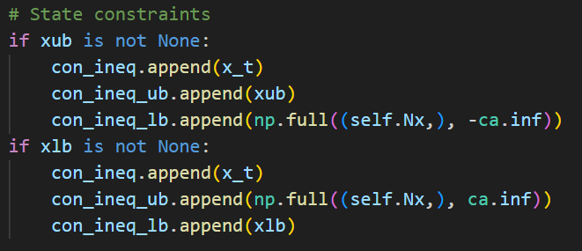

Figure 5 - State constraints

1. The object function is formulated by summing the running cost over every timestep and adding the terminal cost once at the end. The entries of the cost function are the difference between x_t and x0_ref, the weighting matrices Q and R as well as the control signal u_t. Regarding the terminal cost the difference between the last state and the reference state is penalized by matrix P.

Figure 6 - Object function

1. The terminal constraints are included by adding inequality constraints for the final state x_N. The inequality constraints upper bound is set by using the offsets of the polytope and the lower is set to minus infinity. The following inequality holds:

Figure - Terminal constraints

1. The variable param_s concatenates vertically the vectors, x0, x0_ref and u0 in form of a single input vector for the casadi solver. The three input vectors are the start values. The param_s is handed over to the solver as a part of a dictionary to formulate the nonlinear program (nlp). See figure 9.

Figure 8 - Declaration of param_s

Figure 9 – Dictionary for the solver

1. The variable x0 is used to receive the first control input u0 to control the system. See figure 10.

Figure 10 - Usage of x0

**Q4:**

The values for energy use, as well as the position and attitude integral errors obtained when running the simulation with and without expanding the boundaries of can be found in table 1.

Table 1

|  |  |  |  |
| --- | --- | --- | --- |
|  |  |  | Percentual change |
| Energy use | 156.2 | 160.5 | +2.75% |
| Position integral error | 3.94 | 3.55 | -9.9% |
| Attitude integral error | 0.9 | 0.88 | -2.2% |

From the table it can be seen that an increase of the boundaries of with a factor of 3 results in an increase of energy usage while the integral errors decrease. This is reasonable since a larger set of control inputs has the possibility to decrease the errors further on a limited horizon compared to a small set. But it comes with the cost of being more energy consuming. The percentual changes show that error reduction is higher than the increase of used energy.

Figure 11 - Simulation with u_lim

Figure 12 - Simulation with 3*u_lim

From the simulations it can also be seen that the position is reached slightly faster when the boundary of the input signal is increased by a factor of 3.

**Q5:**

When setting the terminal set to the problem becomes infeasible. By comparing the invariant set obtained by (figure 13) with the invariant set in Q1 (figure 14), it has decreased significantly which makes the initial state appear outside the set. As a result, there is no solution for the MPC problem.

Figure 13 - Invariant set with terminal set as zero

Figure 14 - invariant set from Q1

**Q6:** The problem becomes feasible again when changing the horizon length from to . But the computational time is increased. With the computational time is approximately 18 seconds. This can be compared to the computational time of which is 44 seconds.

Regarding the time to solve the MPC problem it took around 0.04 to 0.11 seconds for to solve it. For it took around 0.12 to 0.2 seconds to solve it which is an increase of approximately factor 2.

**Q7:**

* **By multiplying R with a factor 10**, the energy used is decreased to 100.61. This decrease is reasonable since the control penalty is increased and therefore the optimal solution is found with smaller control inputs. The integral error of the position is 5.82 and for the attitude 0.91, which is an increase in both cases. As a drawback the astrobee reaches its final position after approximately 6 seconds compared to to 4.5 seconds for the standard case. It also uses a smaller force input with a maximum of 0.13 N which can be compared to 0.3 N for the standard case.
* **By adding 100 to the velocity components of Q,** the energy used is reduced to 32 with the drawback of increased positional integral error to 18 and attitude integral error of 7. The astrobee will not reach its final position within simulation time of 20 seconds. The maximum velocity is decreased 0.017 m/s. This can be compared to the standard case when the maximum of approximately 0.075 m/s.
* **By adding 100 to the positional components of Q,** the MPC problem becomes infeasible. Since the position and attitude is penalized to high there is no invariant set found.
* **By increasing all elements of Q with 100,** theenergy used is